**Dental Application Documentation**

**Table of Contents**

1. **Introduction**
2. **Features Overview**
3. **System Architecture and Flow**
4. **Database Design and Entities**
5. **User Interaction Flow**

**1. Introduction\*\***

**Project Name: Dental Application**

**Objective:**

The Dental Application is designed to streamline the operations of a dental practice by providing a digital platform to manage various activities related to patients, doctors, treatments, and appointments. This application aims to improve the efficiency of administrative tasks, reduce paperwork, and enhance the overall experience for both staff and patients.

The goal is to create a comprehensive and user-friendly application that allows users to:

* Manage Patient Information: Easily store and update patient details, including their medical history, contact information, and treatment history.
* Schedule Appointments: Simplify the process of scheduling and managing appointments between patients and doctors, ensuring that patients can easily book or cancel appointments online.
* Treatment Management: Keep track of various treatments offered by the dental practice, including their costs, assigned doctors, and patient records.
* Doctor Management: Maintain up-to-date details about the medical staff, including their areas of expertise, contact information, and scheduled appointments.

By automating these functions, the system ensures smoother coordination between different components of the practice. The application helps users, including administrative staff and patients, to stay organized and up-to-date, improving the workflow and saving time. Additionally, the system is designed with a clean, responsive interface, ensuring easy navigation and accessibility on both desktop and mobile devices.

**Technologies used**

* **Frontend:** Angular, TypeScript, HTML, CSS

**2. Features Overview**

This section covers the main features of the Dental Application.

1. **Patient Management:**
   * Add, update, and delete patient details.
   * View a list of all patients.
   * Assign treatments to patients.
2. **Doctor Management:**
   * Add, update, and delete doctor details.
   * Display a list of doctors with specialties and contact information.
3. **Treatment Management:**
   * Display various treatments and their details.
   * Assign doctors to treatments.
   * Display treatment history for each patient.
4. **Appointment Scheduling:**
   * Create, view, and delete appointments.
   * Link appointments to specific doctors and treatments.
5. **User Interface:**
   * A clean, responsive UI for easy navigation.
   * Interactive components for managing records, appointments, and doctor details.

**3. System Architecture and Flow**

The system architecture consists of various components like the home page, patient management, doctor management, and treatment management. Below is the flow chart that illustrates how the different modules are connected:

**Flowchart: System Workflow**

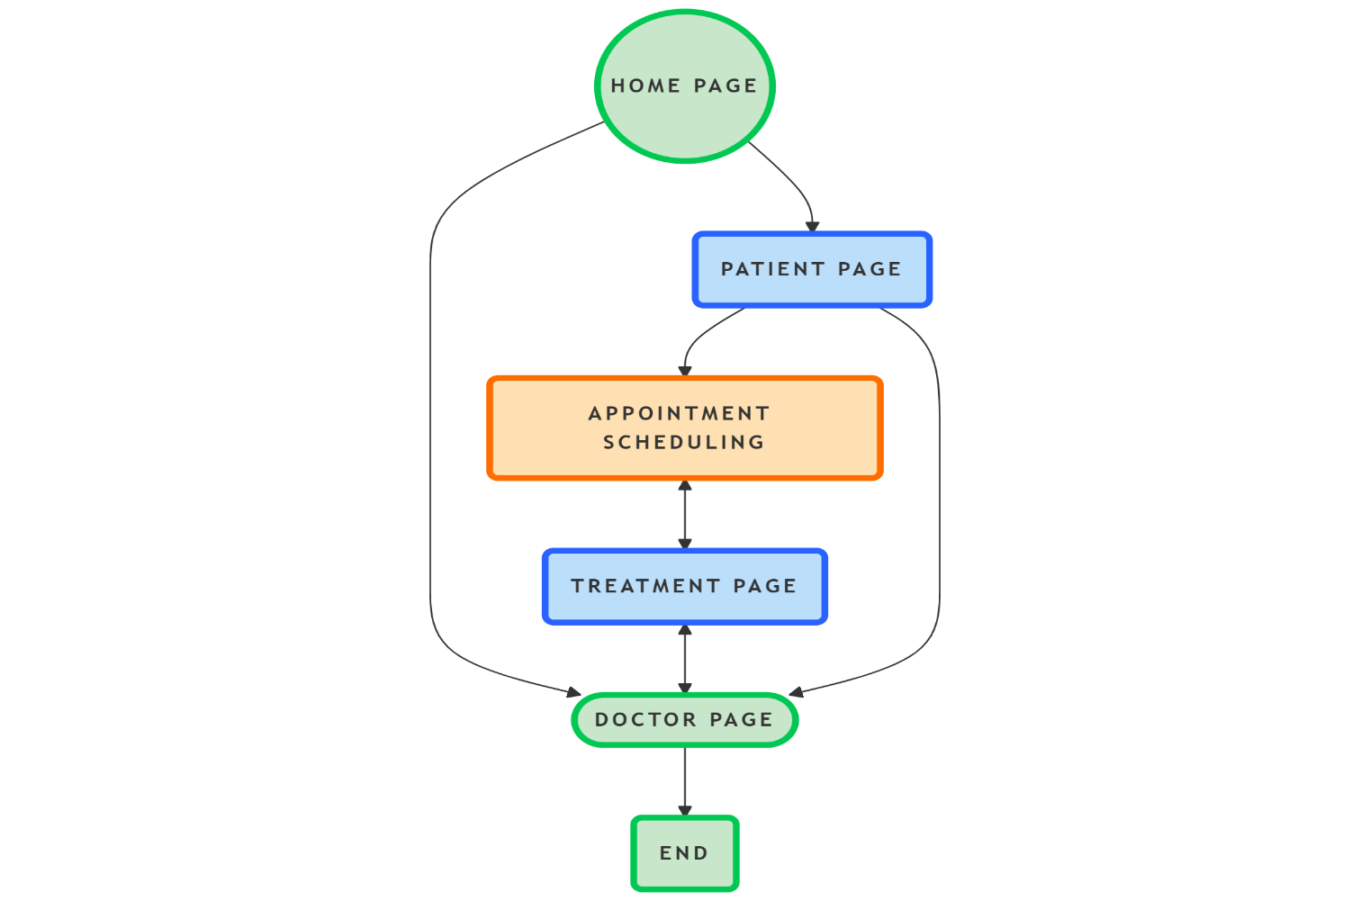

**4. Database Design and Entities**

The database design ensures that all relevant data is stored and accessed efficiently. We have several core entities like Doctor, Patient, Treatment, and Appointment.

**Entities:**

1. **Doctor:**
   * id: Primary key
   * name: Name of the doctor
   * specialization: Area of expertise (Dentist, Orthodontist, etc.)
   * contact: Contact number
2. **Patient:**
   * id: Primary key
   * name: Name of the patient
   * contact: Contact details of the patient
   * dob: Date of birth
   * medical_history: Notes on medical conditions
3. **Treatment:**
   * id: Primary key
   * name: Name of the treatment
   * cost: Cost of treatment
   * doctorId: Reference to doctor providing the treatment
4. **Appointment:**
   * id: Primary key
   * patientId: Reference to the patient
   * doctorId: Reference to the doctor
   * appointment_date: Date and time of the appointment
   * treatmentId: Treatment assigned for the appointment

**5. User Interaction Flow**

This section describes the typical user flow for interacting with the application.

1. **Home Page (Landing Page):**
   * The user is greeted with the landing page and can navigate to different sections like Patients, Doctors, Treatments, and Appointments.
2. **Doctor Page:**
   * The user can view a list of doctors. Clicking on a doctor’s name shows more details about the doctor.
3. **Patient Page:**
   * The user can add a new patient, view patient details, or edit the existing patient records.
4. **Treatment Page:**
   * The user can view a list of treatments and assign them to specific patients.
5. **Appointment Scheduling:**
   * The user selects a patient and a doctor to create an appointment. The appointment is scheduled with a treatment and can be saved in the system.

**Flowchart: User Interaction Workflow**

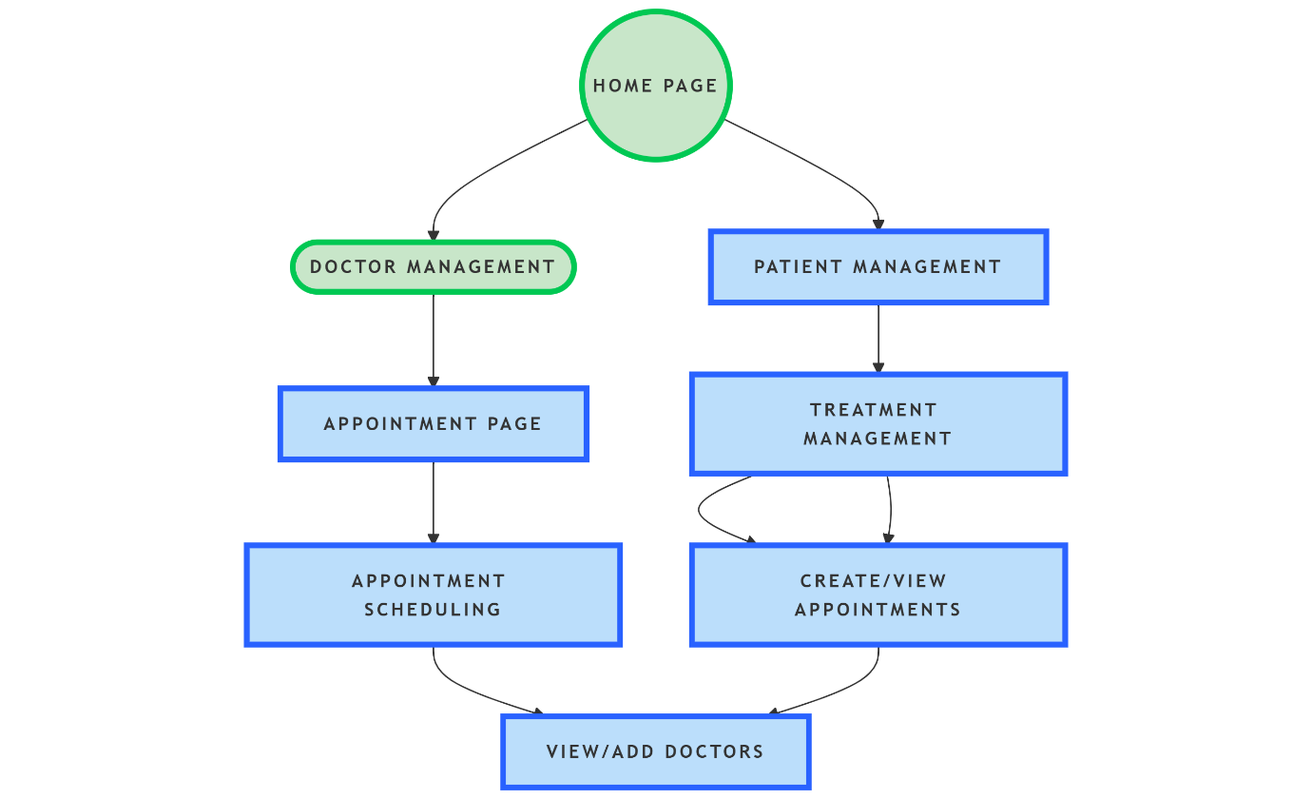

**Conclusion**

This Dental Application provides a smooth interface for managing patients, doctors, treatments, and appointments. The architecture ensures scalability and flexibility for future enhancements, like adding new features, optimizing user experience, or integrating with third-party services.

By following the system's architecture and user flow, you can ensure a user-friendly experience, making it easier for administrators and staff to manage the dental practice efficiently.